15 Steps

Workflow with localhost

Created By
Puja Gurung
Updated
Sep 21, 2026
View latest
Open in Tango

Home | Bundoora Family Clinic


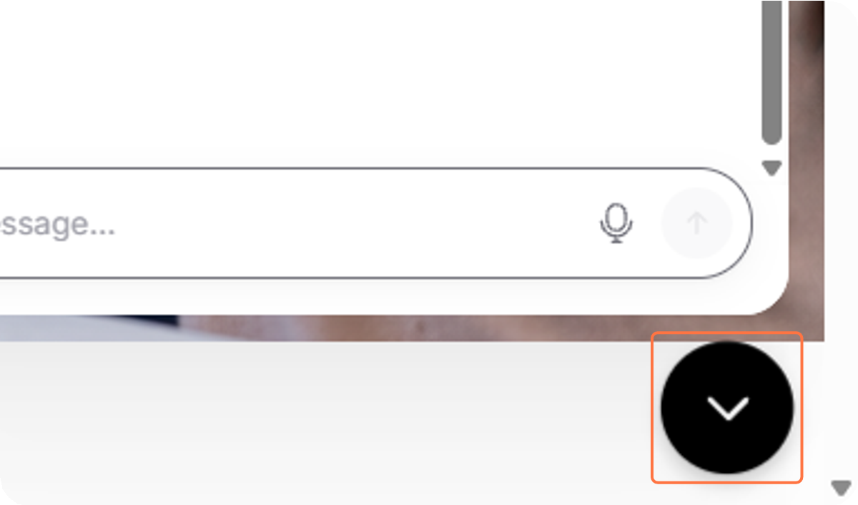
Click on Close
1

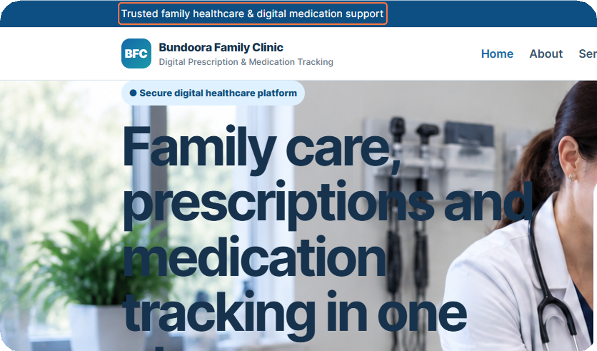
Click on Trusted family health-care & digital medication support
2

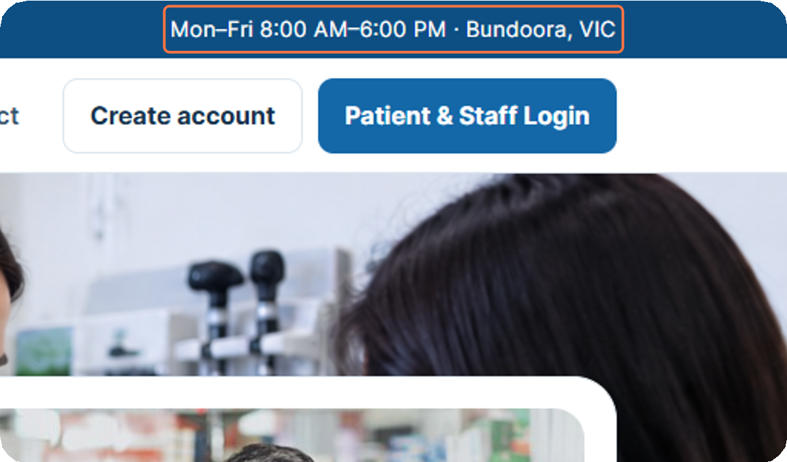
Click on Mon–Fri 8:00 AM–6:00 PM · Bundoora, VIC

3

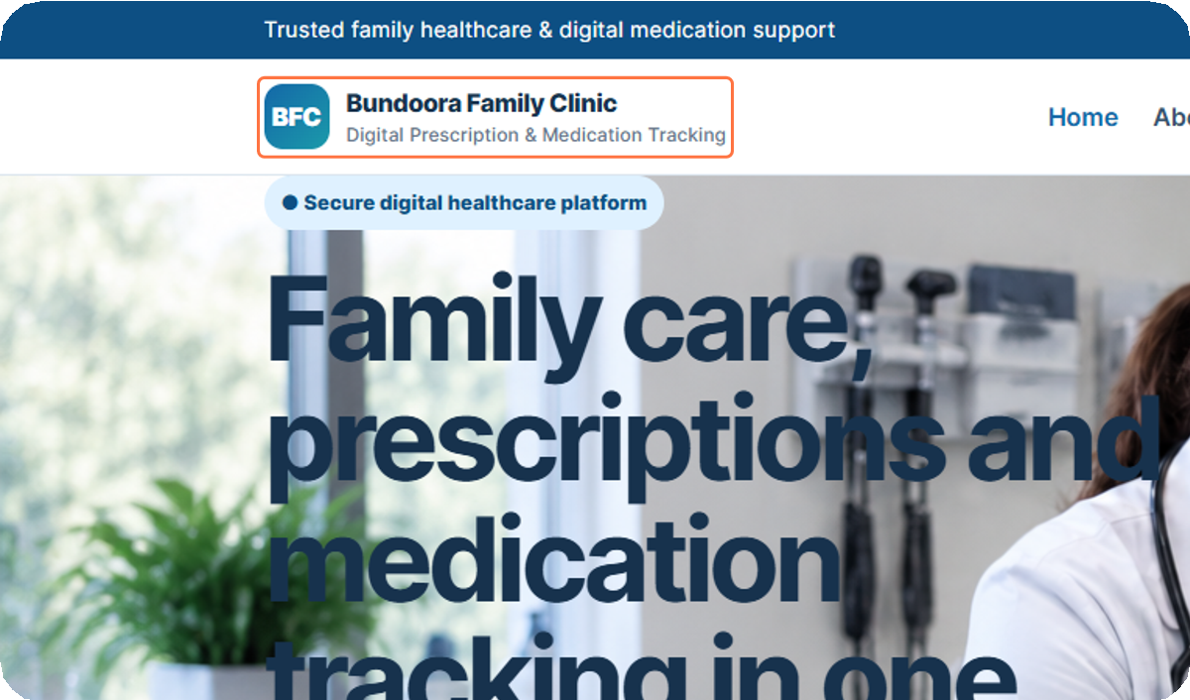
Click on BFC…
4


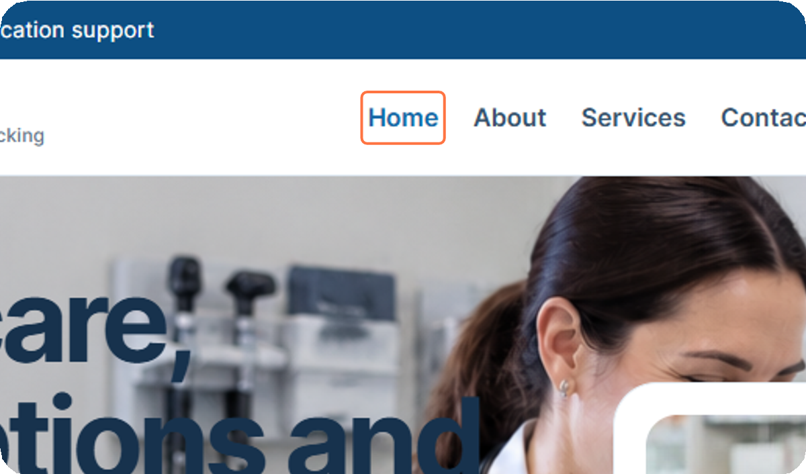
Click on Home
5

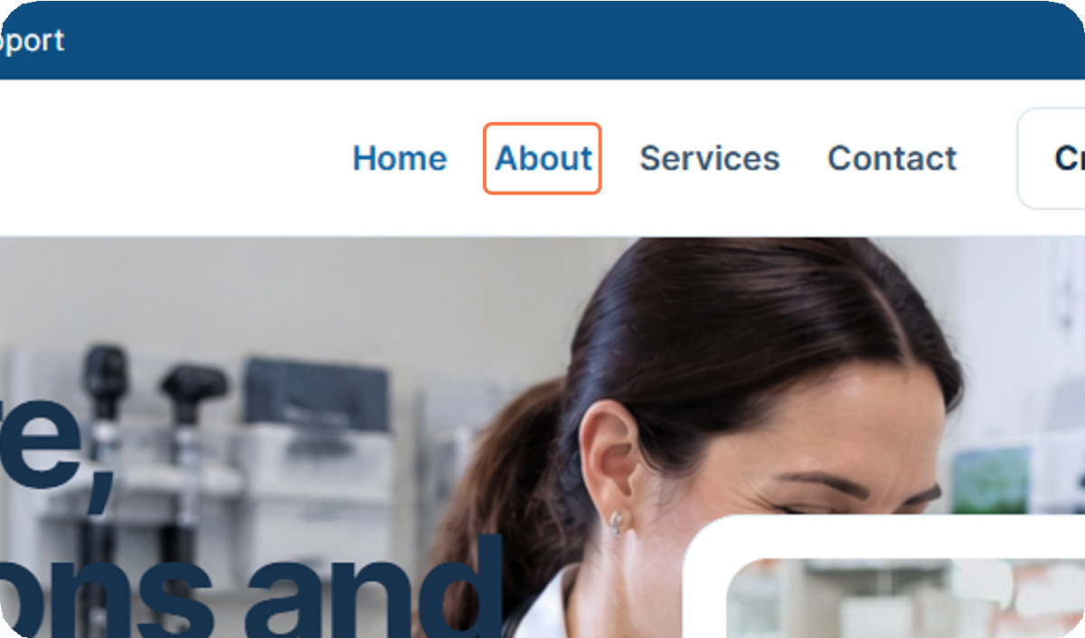
Click on About

6

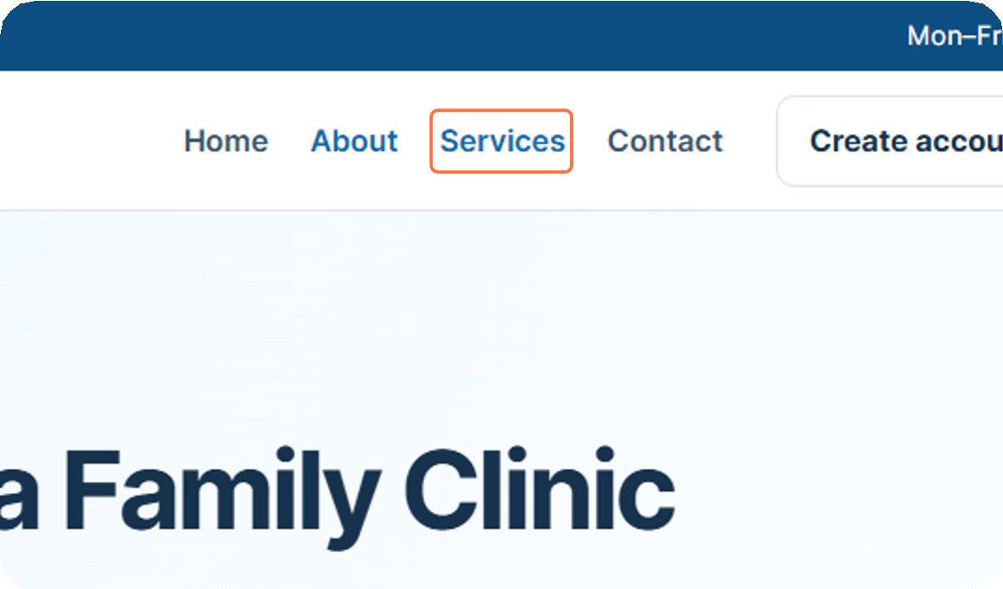
Click on Services
7

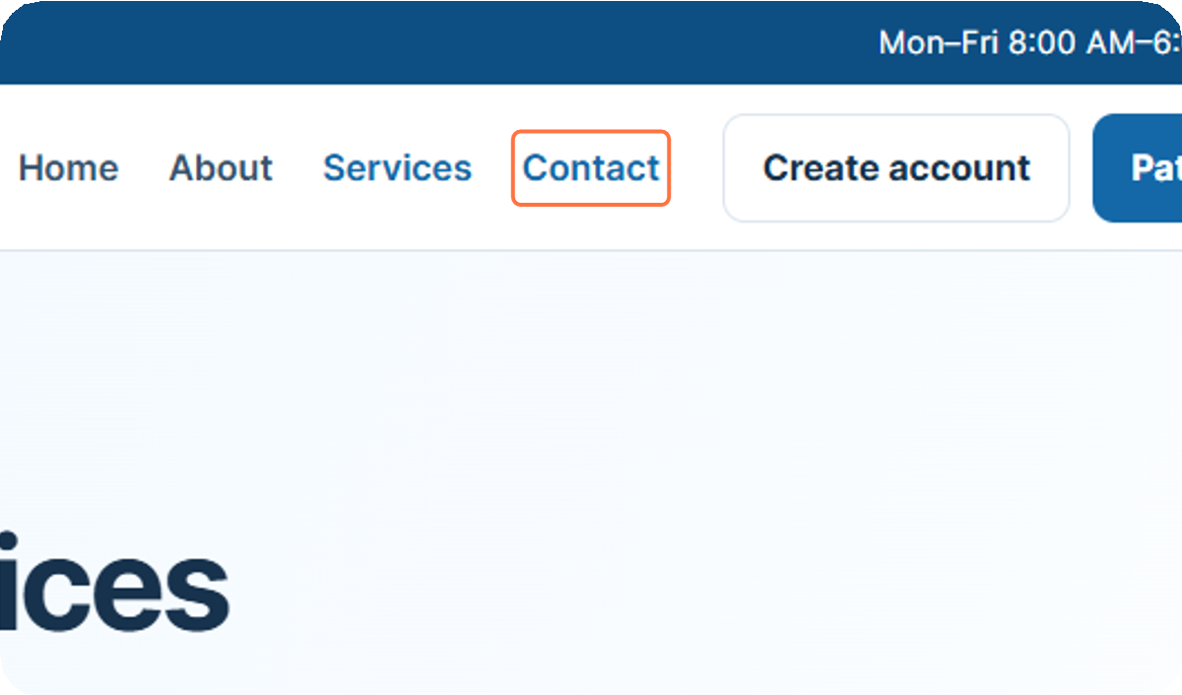
Click on Contact

8

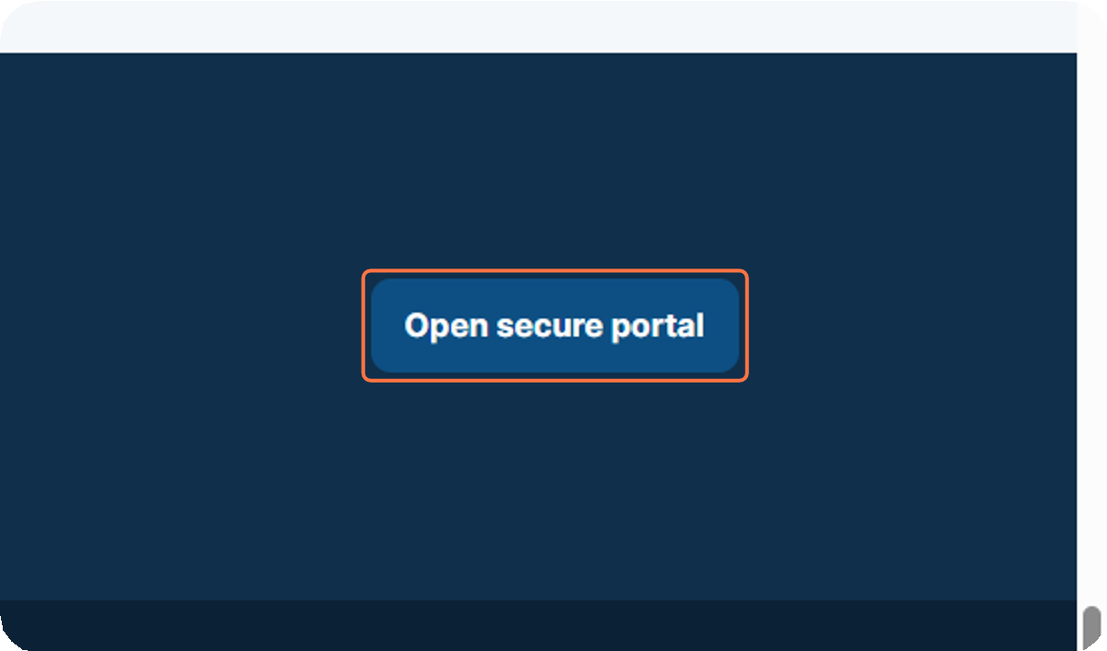
Click on Open secure portal
9

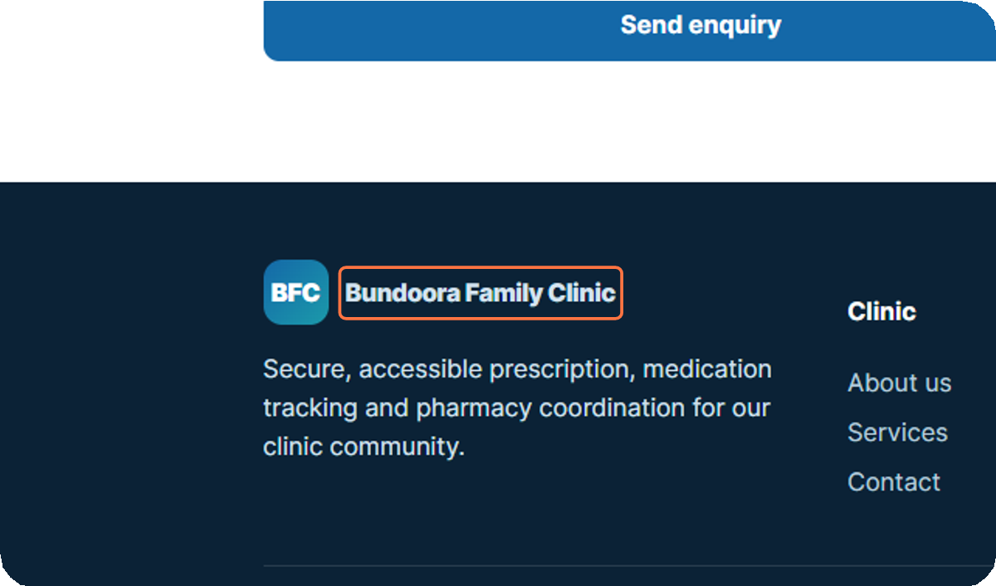
Click on Bundoora Family Clinic
10

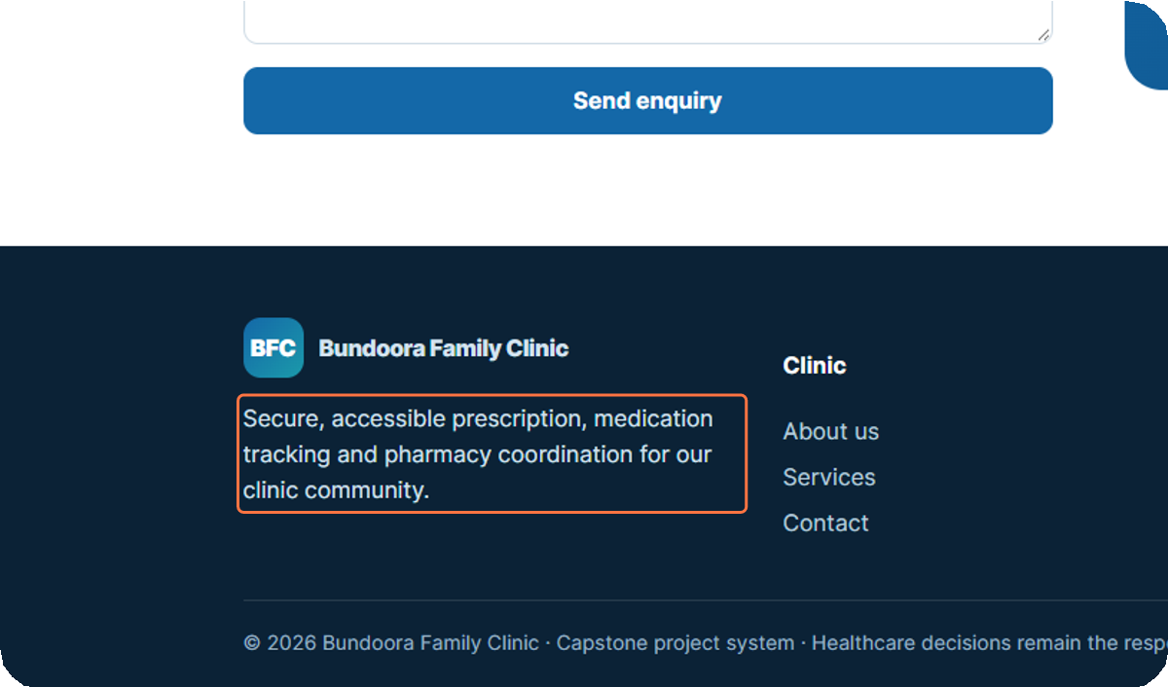
Click on Secure, accessible prescription, medication tracking and pharmacy coordination for our clinic community.

11

12

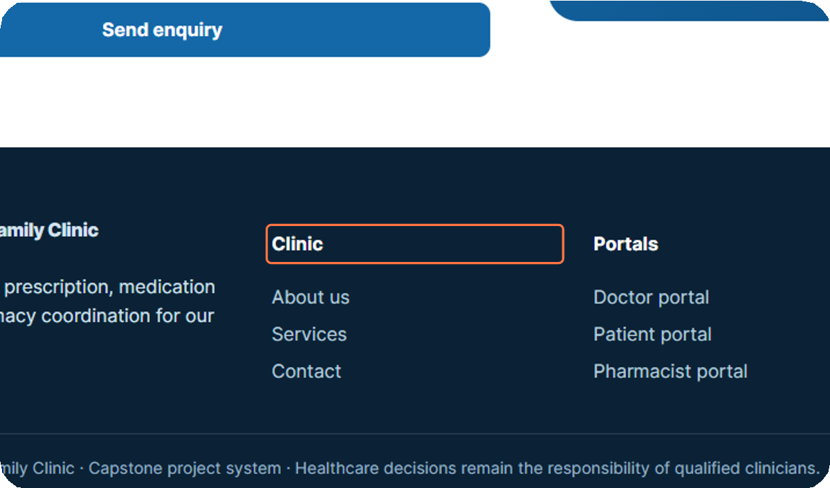
Click on Clinic

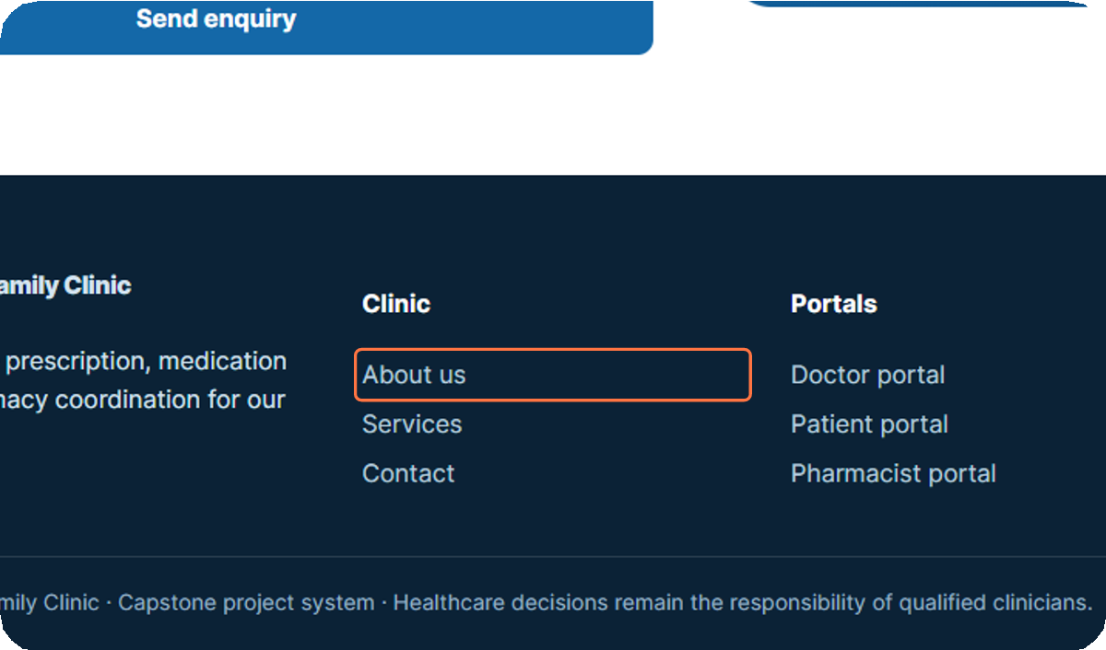
Click on About us
13

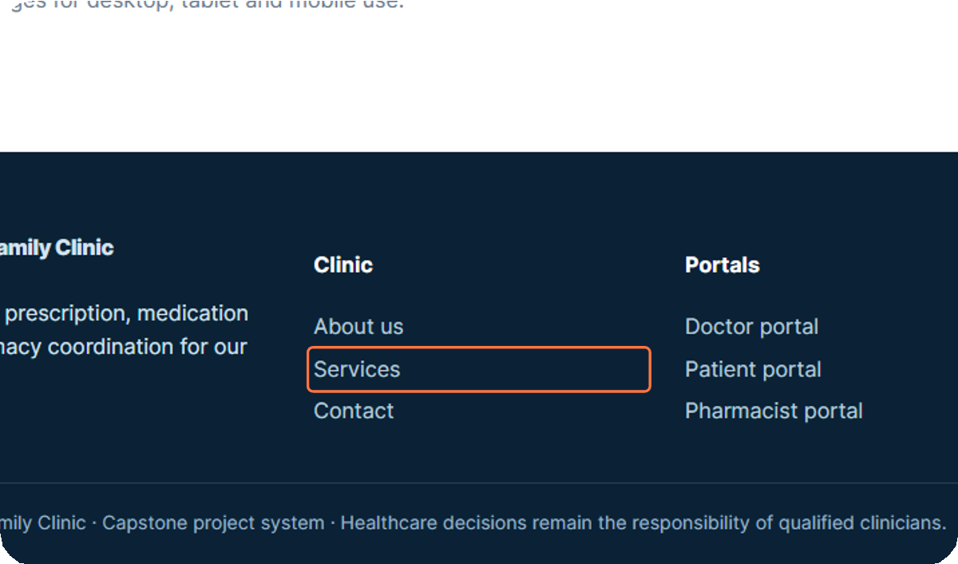
Click on Services

14

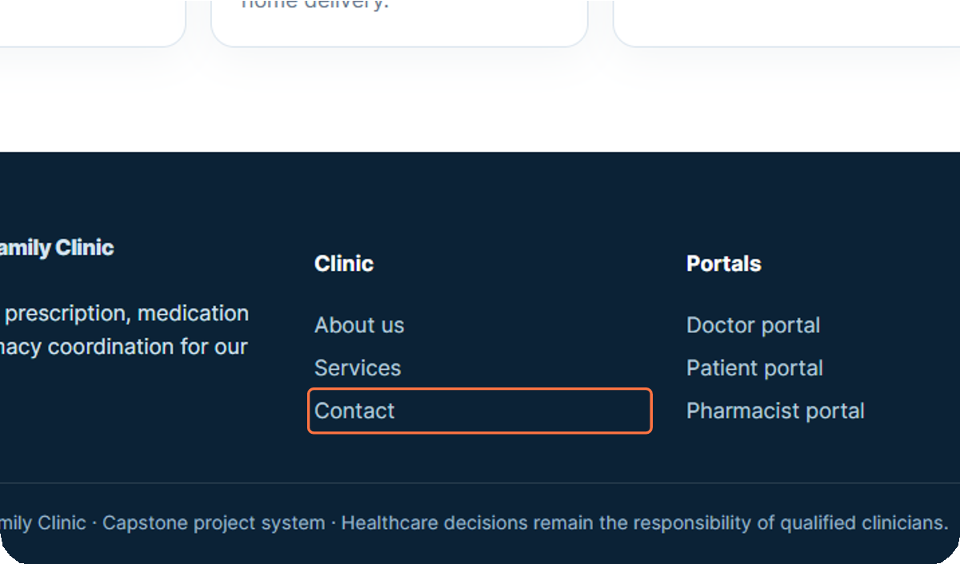
Click on Contact

15

